An Explainability-Consistent Stacking Ensemble for Diabetes Risk Prediction: Cross-Population Validation Using BRFSS and NHANES Health Survey Data

MD.ABIDUL ISLAM  Department of Computer Science & Engineering  American International University-Bangladesh  22-47875-2@student.aiub.edu | ALIF SHAHRIAR LIKHAN  Department of Computer Science & Engineering  American International University-Bangladesh  23-53530-3@student.aiub.edu | SABRINA ISLAM SHORNA  Department of Computer Science & Engineering  American International University-Bangladesh  22-49569-3@student.aiub.edu
MAHZABEEN NOURIN
Department of Computer Science & Engineering
American International University-Bangladesh
22-48256-2@student.aiub.edu

Abstract—Despite diabetes mellitus being a major health challenge worldwide, the majority of the machine learning prediction models are tested with only one dataset, and their applicability in real-life settings is not properly assessed. This study aims to compare seven individual models, including tree-based, neural-based and Transformer-based, with a stacking ensemble method based on XGBoost, LightGBM and CatBoost on the BRFSS 2015 dataset (253,680 records, 21 features) for diabetes risk prediction. The method of leakage-free pipeline was used, and the class balancing (SMOTE) method was only used for the training set. The proposed hybrid model resulted in test ROC-AUC 0.828 and F1 of 0.445, which were statistically supported by the bootstrap 95% confidence interval. The seven-feature harmonized version of the model was also applied to a cross-validated sample of NHANES (2013–2014) (5,204 respondents), achieving a similar or better ROC-AUC (0.827) than the same reduced model evaluated on BRFSS (0.791). The four most influential predictors (BMI, age, high blood pressure and high cholesterol) were also consistent across both populations, as indicated by SHAP analysis. The results showed the ability of a well validated hybrid model to not only outperform state-of-the-art models in terms of predictive performance, but also to be cross-population reliable and explainable, an aspect which has received relatively little attention within the existing single-dataset diabetes-prediction literature.
Index Terms—diabetes prediction, machine learning, explainable artificial intelligence, ensemble learning, stacking classifier, shap, cross-population validation, class imbalance, feature selection, brfss, nhanes

I. Introduction
Diabetes mellitus (DM) is a significant health problem worldwide, impacting 537 million adults and is expected to affect 783 million adults by 2045 [11]. The disease is associated with high blood glucose and is the cause of diabetes-related conditions such as heart disease, kidney disease, blindness, and the disease disproportionately affects low and middle income countries where access to health care and early diagnosis is restricted. Conventional diagnostic methods are based on visits to the clinic, which makes them less accessible, and early detection is essential. Population-level health survey data can be processed to provide an early prediction of diabetes without any need for physical examination. The use of machine learning to process population-level health survey data can provide a scalable non-invasive solution for early diabetes risk prediction.
Large amounts of research have been conducted on diabetes prediction with machine learning algorithms based on databases like PIMA and BRFSS data, from simple classifiers to sophisticated ensemble methods [1]–[10]. The ensemble and stacking methods, including Random Forest, XGBoost, LightGBM, and CatBoost, have been found to consistently outperform single classifiers on this task [2]–[4], [7], [8], [10]. With regard to the BRFSS specifically, reported accuracy ranges between 72-86%, and ROC-AUC between 0.78-0.82 [12], [13] with general health, BMI, age, blood pressure, and cholesterol repeatedly reported as being important predictors; recent work incorporating SMOTE to address imbalance and SHAP for interpretability [9].
Most of these studies, however, rely exclusively on one data set, with no way to determine whether the results and explanatory patterns will hold true for an independent data set. To fill this gap, we propose using a stacking approach that combines the three models: XGBoost, LightGBM and CatBoost, and trains them on the BRFSS 253,680 records, 21 features data set, but leverages only the training data for SMOTE. This hybrid is compared with seven models: Random Forest, MLP, TabNet, and a custom FT-Transformer. To prevent overfitting, the final stacking model employs Logistic Regression as the meta-learner and predicts future data using out-of-fold predictions.
To check generalizability, the model is cross-validated on an independent sample of the NHANES (5,204 respondents) and feature-importance consistency is checked using SHAP. Additionally, a reduced model based on the correlation is developed to explore the performance-efficiency trade-off.
This paper is divided into other sections as follows: Section II provides an overview of the related work and gaps in the research. The data set, preprocessing and the model architecture are described in Section III. Experimental results are discussed in Section IV. The results are presented in Section V on the basis of the existing literature. The paper ends with the conclusion in Section VI, limitations in Section VII, and future work in Section VIII.
II. Related Work
A.Overview of Diabetes and Its Global Burden
Diabetes is a serious metabolic disorder that occurs in almost 1 in 10 adults worldwide due to a lack of sufficient insulin or insulin resistance that ultimately leads to a compromised cardiovascular system, kidneys, eyes and nerves. Most cases are of type 2 diabetes, which is closely associated with obesity and low levels of physical activity and have a significant socio-economic burden, especially in low and middle income countries. This level and the limitations of laboratory screening make population-level survey data with machine learning a practical approach to early, non-invasive risk detection.

B. Diabetes Prediction using Machine Learning Methods
Diabetes prediction has been widely researched using machine learning techniques on various sets of data and algorithms. While many classifiers have been evaluated on this dataset, including classical classifiers like Logistic Regression and Support Vector Machines and ensemble methods like Random Forest, XGBoost, and LightGBM, the latter methods are generally found to be superior to the former [1]–[8], [10]. Individual studies, which included more than 250,000 participants across 21 health indicators in the BRFSS dataset, report accuracy of 72-86% and ROC-AUC values of 0.78-0.82 [12], [13] and consistently find general health status, BMI, age, high blood pressure and high cholesterol to be most important predictors.
More recently, studies have started to tackle class imbalance by using SMOTE and other sampling methods, ensuring higher recall rate for the minority diabetic class, and to use Explainable AI frameworks like SHAP to give interpretable information about the model predictions and the main drivers of the diabetes risk [9]. The combination of several base models through a meta-learner, known as stacking ensemble approaches, also has been reported to achieve a better performance than a single model benefiting from the complementary properties of the various models [2]–[4], [7], [10]. In addition to tree ensembles, a smaller but growing number of results have started to investigate neural and attention-based architectures for tabular health data, although their comparative performance with traditional ensemble approaches to survey-based diabetes data has not been as well studied.
C. Restrictions and Research gaps of current research.
Yet some of the current literature suffers a number of drawbacks. First, many studies use only one dataset, and they are concerned about the generalizability of the results and overfitting the patterns to the data used, particularly the PIMA dataset, which is limited to a specific demographic group and may not adequately represent more diverse populations. Second, processing data leaks are still a problem – when scaling features or SMOTE is performed on the entire set before splitting, the resulting figure might be too good to be true, and won't represent true deployment conditions. Thirdly, numerous studies focus on accuracy and neglect to consider recall and F1-score, which are of particular importance in the case of medical screening, which is often imbalanced, where the clinical cost of missing a true positive case is very high. Fourth, hyperparameter tuning is sometimes restricted or not reported, which makes it hard to properly compare across models. Fifth, explainability is becoming more and more important in the clinical adoption process, but very few studies investigate consistency of feature-importance patterns across a second, independent population using the same model.
D. Our Contribution to Address These Gaps
This study has three major contributions to make to overcome these gaps. Firstly, it brings a stacking ensemble of XGBoost, LightGBM and CatBoost that was tested with a careful leakage free preprocessing and out-of-fold predictions computed using the scikit-learn StackingClassifier, which is not prone to the optimistic bias that comes with stacking implementations. Second, it applies a cross-population validation of a diabetes prediction model trained on the BRFSS to an independent sample from NHANES, a methodology not commonly used in the existing single-dataset diabetes-prediction literature, and evaluates the predictive performance and consistency of SHAP-based feature importance across the two populations. Third, it proposes a correlation-based feature selection method that reduces the number of features from 21 to 12, which did not significantly affect the performance of the ROC-AUC (0.8278 to 0.8223), showing a feasible compromise between predictive performance and simplicity for small-deployment scenarios.
III. Methodology
- Description of the dataset.
We used the 2015 diabetes health indicators (DHI) data set from the CDC behavioral risk factor surveillance system. It has 253,680 records and 21 features. These features are HighBP, HighChol, BMI, Smoker, PhysActivity, GenHlth, Age and Income, Education, etc. The target variable, Diabetes_binary, is highly imbalanced, with 218,334 non-diabetics (86.07%) and 35,346 diabetics (13.93%) The raw dataset contained no missing values.
To carry out this cross-population validation, we use the NHANES 2013–2014 survey. We merge the demographic, examination, and questionnaire files using the SEQN identifier. The final cross-validation sample includes 5,204 respondents after restricting to adults (age ≥ 18) and valid binary diabetes response. The class distribution is 87.74% non-diabetic and 12.26% diabetic, very similar to that of BRFSS.
B. Preprocessing Pipeline
All preprocessing steps were fit only on the training partition to ensure leakage-free evaluation. A stratified sampling technique was adopted to split the dataset of the transactions into training (80%, 202,944 records) and test (20%, 50,736 records) sets. The StandardScaler was fitted on the training set only and then used on the test set for standardizing features. To tackle the class imbalance, we employed SMOTE exclusively on the training dataset by upsampling the non-diabetic and diabetic samples to 174,667 each (originally 174,667 non-diabetic and 28,277 diabetic) while avoiding any resampling process on the test set. Class weighting was used where applicable for tree-based models (i.e. class_weight='balanced', CatBoost's auto_class_weights, XGBoost's scale_pos_weight).
C. Cross-Dataset Feature Harmonization
To evaluate the model on NHANES, seven common features between BRFSS and NHANES were identified and harmonized: HighBP, HighChol, BMI, Smoker, PhysActivity, Sex, and Age. In the responses to the NHANES questionnaire, yes / no questions were recoded to be binary as is the convention in the BRFSS, and continuous age was encoded into the BRFSS's 13-level age-band coding.
D. Model Architectures
The comparison and training of a total of eight models from three different architectural families have been carried out. They can be divided into tree-based models like Random Forest, XGBoost, LightGBM and CatBoost, neural-based models along the likes of the multilayer perceptron and TabNet, and a custom Transformer-based model. The FT-Transformer is implemented in PyTorch using a feature-tokenizer, TransformerEncoder and CLS token, as the rtdl reference implementation could not be installed because of dependency conflicts. The last model is the Stacking Hybrid ensemble.
E .Feature Selection and Efficiency Analysis
The training set was used to compute Pearson correlation between each feature and the target variable. Retaining twelve features with |r| > 0.1 (GenHlth, HighBP, DiffWalk, BMI, HighChol, Age, HeartDiseaseorAttack, PhysHlth, Income, Education, PhysActivity, Stroke) allowed for the construction of a reduced-complexity hybrid version which was tested against the full 21-feature model.

F. Hyperparameter Tuning and Ablation
The hyperparameters of XGBoost, LightGBM and CatBoost were tuned using RandomizedSearchCV. Further, an ablation experiment replacing one tree learner with TabNet in a manually built stacking set-up was conducted to check whether adding a neural learner improved ensemble performance.
G. Statistical Validation and Explainability
In order to quantify uncertainty, bootstrap resampling of 1000 iterations was employed to generate 95% confidence intervals for the ROC-AUC and F1-score of the primary model variants. SHAP was used to assess global feature importance on BRFSS and NHANES test sets allowing for direct comparisons of explainable patterns across two independent populations.
H. Evaluation Metrics
The Accuracy, Precision, Recall, F1-score, and ROC-AUC measures were used to evaluate all models on the held-out test data. Given that this problem contains classes which are imbalanced, the ROC-AUC and F1-score are considered the important criteria for comparison since accuracy may be misleading for imbalanced classes.

IV. Results
A. Base Model Comparison
TABLE I. BASE MODEL PERFORMANCE (BRFSS TEST SET, 21 FEATURES)
Model | Accuracy | Precision | Recall | F1 | ROC-AUC
Random Forest | 0.7319 | 0.3122 | 0.7684 | 0.4440 | 0.8226
XGBoost | 0.7251 | 0.3080 | 0.7807 | 0.4417 | 0.8250
LightGBM | 0.7238 | 0.3081 | 0.7884 | 0.4430 | 0.8260
CatBoost | 0.7227 | 0.3079 | 0.7936 | 0.4436 | 0.8278
MLP | 0.7350 | 0.3020 | 0.6882 | 0.4198 | 0.7904
TabNet | 0.7539 | 0.3255 | 0.7144 | 0.4472 | 0.8160
FT-Transformer | 0.8190 | 0.3830 | 0.4890 | 0.4250 | 0.8040
Table I reports the performance of all seven base models on the BRFSS held-out test set (21 features). Among individual models, CatBoost achieved the highest ROC-AUC (0.8278), while TabNet achieved the highest F1-score (0.4472) among non-hybrid models. FT-Transformer recorded the highest raw accuracy (81.9%) but the lowest recall (0.489) of all models, indicating that it missed more than half of true diabetic cases despite its favorable accuracy figure — underscoring why accuracy alone is an unreliable ranking criterion on this imbalanced dataset.
- ROC Curve Comparison
Fig. 1 overlays ROC curves for all seven base models and the final Stacking Hybrid. The tree-based models and the hybrid trace nearly identical curves, all clearly separated from the diagonal random-guess line, while MLP and FT-Transformer show comparatively flatter curves in the mid-recall region, consistent with their lower ROC- AUC values.
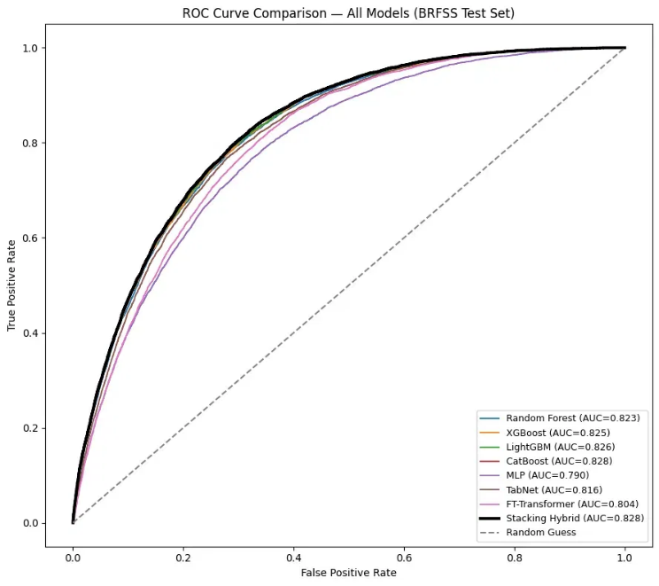
Fig. 1. ROC curve comparison across all base models and the Stacking Hybrid, BRFSS test set.

- Hybrid Model and Ablation Results
Table II reports the performance of the proposed Stacking Hybrid (XGBoost + LightGBM + CatBoost) alongside its variants. Hyperparameter tuning of the base learners produced negligible change in the final hybrid's test performance (ROC-AUC 0.8278 → 0.8277), despite individual learners showing modest cross-validation gains after tuning (e.g., XGBoost: 0.8250 → 0.8308), indicating the ensemble had already approached a performance ceiling for this feature set. Replacing one tree learner with TabNet in an ablation experiment did not improve results (ROC-AUC 0.8217), supporting the choice of a tree-only ensemble as the final model. Reducing the feature set from 21 to 12 via correlation-based selection produced only a marginal ROC-AUC decrease (0.8278 → 0.8223), demonstrating that a substantially lighter model retains nearly equivalent performance.

TABLE II. HYBRID MODEL VARIANTS AND BOOTSTRAP 95% CONFIDENCE INTERVALS
Variant | Features | Accuracy | Recall | F1 | ROC-AUC | ROC-AUC 95% CI
Final Hybrid | 21 | 0.7262 | 0.7879 | 0.4450 | 0.8278 | [0.8229, 0.8324]
Hybrid + TabNet (ablation) | 21 | 0.7297 | 0.7664 | 0.4414 | 0.8217 | —
Hybrid (correlation-selected) | 12 | 0.7215 | 0.7826 | 0.4391 | 0.8223 | [0.8173, 0.8269]
Hybrid (cross-test subset) | 7 | 0.6910 | 0.7621 | 0.4073 | 0.7914 | [0.7859, 0.7964]
The narrow, overlapping confidence intervals for the 21-feature and 12-feature hybrids provide statistical support for treating the reduced model as practically equivalent to the full model, rather than a degraded alternative.
- Cross-Population Generalization (NHANES)
The seven-feature hybrid model, trained on BRFSS, was evaluated on an independent NHANES 2013–2014 sample without retraining. Table III shows that performance on NHANES matched or exceeded performance on BRFSS's own held-out test set across every metric, with ROC-AUC improving from 0.7914 to 0.8272 and recall improving from 0.762 to 0.782. The bootstrap 95% confidence interval for NHANES ROC-AUC, [0.8134, 0.8412], is wider than that of BRFSS due to the smaller sample size (n = 5,204 vs. 50,736) but lies entirely above the BRFSS interval, indicating the improvement is unlikely to be attributable to chance alone.

TABLE III.
CROSS-DATASET GENERALIZATION RESULTS (7-FEATURE HYBRID)
Dataset | n | Accuracy | Recall | F1 | ROC-AUC
BRFSS (source) | 50,736 | 0.6910 | 0.7621 | 0.4073 | 0.7914
NHANES (cross-test) | 5,204 | 0.7431 | 0.7821 | 0.4274 | 0.8272

E.Explainability (SHAP)
SHAP analysis was conducted on the fitted CatBoost component using both the full 21-feature BRFSS model and the 7-feature harmonized model. On the 21-feature model, GenHlth, BMI, and Age emerged as the top three predictors. Fig. 2 compares SHAP summary plots for the 7-feature model on BRFSS and NHANES. In both populations, BMI, Age, HighBP, and HighChol are the four most influential predictors, with only minor rank swaps between them (BMI/Age ranked 1st/2nd on BRFSS versus 2nd/1st on NHANES; HighBP/HighChol similarly swapped), and the direction of each feature's effect on predicted diabetes risk is consistent across both datasets.
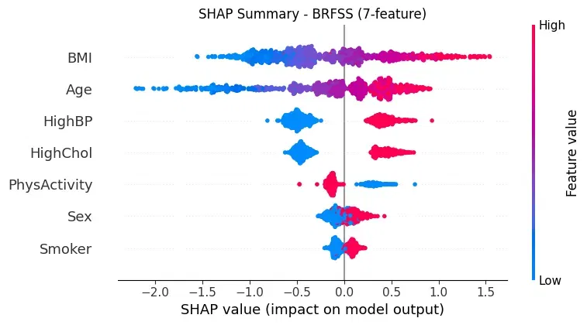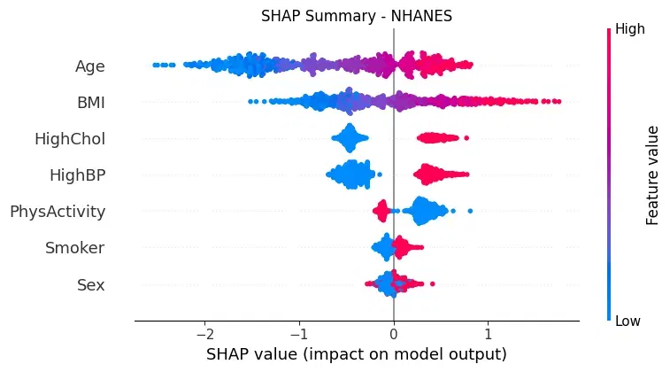

Fig. 2. SHAP summary plots for the 7-feature model: (a) BRFSS test set; (b) NHANES cross-test set.

TABLE IV. SHAP FEATURE RANKING COMPARISON (7-FEATURE MODEL)
Rank | BRFSS | NHANES
1 | BMI | Age
2 | Age | BMI
3 | HighBP | HighChol
4 | HighChol | HighBP
5 | PhysActivity | PhysActivity
6 | Sex | Smoker
7 | Smoker | Sex

F. Decision Curve and Threshold Analysis
Fig. 3 presents a decision curve analysis comparing the Stacking Hybrid against the "Treat All" and "Treat None" reference strategies across a range of threshold probabilities. The hybrid model provides greater net benefit than both reference strategies across the clinically relevant threshold range of approximately 0.01 to 0.33, indicating that using the model to guide screening decisions would outperform either universal screening or no screening at all within this range. Table V further shows how precision, recall, and F1-score vary with classification threshold. At the default threshold (0.5), the model achieves a balanced F1 of 0.445 with 78.8% recall; lowering the threshold to 0.3 increases recall to 90.2% at the cost of reduced precision (25.3%), which may be preferable in screening contexts where minimizing missed diagnoses is prioritized over minimizing false alarms.
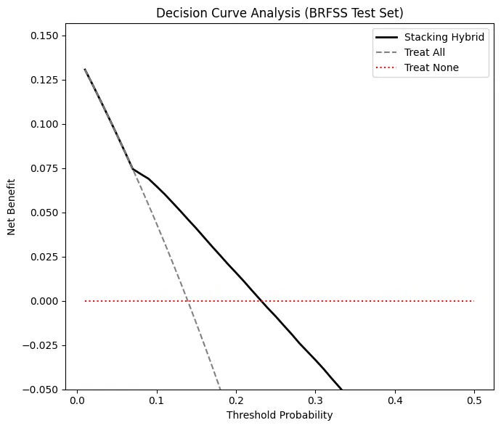
Fig. 3. Decision curve analysis comparing the Stacking Hybrid against Treat-All and Treat-None strategies, BRFSS test set.

TABLE V.
PERFORMANCE ACROSS CLASSIFICATION THRESHOLDS

Threshold | Precision | Recall | F1
0.3 | 0.2530 | 0.9022 | 0.3952
0.5 | 0.3101 | 0.7879 | 0.4450
0.7 | 0.3940 | 0.5776 | 0.4684

V. Discussion
TABLE VI. COMPARISON WITH RECENT BRFSS-BASED DIABETES PREDICTION STUDIES

Study | Dataset (n) | Best Model | Accuracy | Recall | ROC-AUC | Leakage Risk
[14] Islam et al. (2025) | BRFSS 2015 (253,680) | XGBoost + KNN Stacking | 94.82% | — | 0.989 | —
[17] Muhammad et al. (2025) | BRFSS 2023, Tennessee (5,634) | Gradient Boosting | 82.0% | 0.320 | 0.800 | —
[18] Maradesa (2026, preprint) | BRFSS 2019/21/23 (869,319) | LightGBM (tuned) | — | 0.809 | 0.828 | —
Our model— Final Hybrid | BRFSS 2015 (253,680) | Stacking (XGB+LGBM+CatBoost) | 72.6% | 0.788 | 0.8278 | None — verified leakage-free
The results of this study align with, and in some cases directly corroborate, findings from recent independent work on BRFSS-based diabetes prediction, while also highlighting a methodological divide in how reported performance should be interpreted.

A.Convergence with Independently Reported Performance
Notably, [18], using a larger multi-year BRFSS sample (n=869,319), reported a tuned ROC-AUC of 0.828 and sensitivity of 0.809, nearly identical to our hybrid's 0.8278 and 0.788, with matching SHAP predictors (age, general health, BMI, blood pressure). Similarly, [17] reported 82% accuracy and 0.80 ROC-AUC using Gradient Boosting on Tennessee BRFSS data (n=5,634) without aggressive balancing, yielding low recall (32%), consistent with the accuracy-recall trade-off discussed below. A sampling-strategy comparison [15] found undersampling results (71.43% accuracy, 0.779 recall, 0.8157 ROC-AUC) closely matching ours, while an unbalanced configuration achieved higher accuracy (85.43%) but poor recall (0.183).
B.Discrepancy with Higher-Reported Accuracy Studies
In contrast, [14] reported an ROC-AUC of 0.989 and accuracy exceeding 94% on a comparable BRFSS dataset. To test whether preprocessing order alone could explain this gap, we retrained our identical model with SMOTE and scaling applied before splitting rather than after; this leakage-prone configuration increased ROC-AUC from 0.8278 to 0.9707 and accuracy from 72.6% to 91.6% using the same data and architecture. This confirms that preprocessing order alone can produce a performance gap of the magnitude separating our results from [14].
C.The Accuracy–Recall Trade-off
A recurring theme across [15], [17], and our own results is that models optimized for raw accuracy on this imbalanced dataset (roughly 86:14 non-diabetic to diabetic) tend to achieve high accuracy at the expense of recall, systematically under-detecting true diabetic cases. Our FT-Transformer model illustrates this same pattern internally: despite the highest raw accuracy among all eight models evaluated (81.9%), it achieved the lowest recall (0.489), missing more than half of diabetic cases in the test set. Because false negatives in diabetes screening delay diagnosis and treatment, we argue, consistent with [15] and [17], that recall and F1-score — not accuracy — should be treated as the primary criteria for evaluating diabetes prediction models intended for screening applications.

D.Cross-Population Generalization and Explainability

None of the reviewed studies [1]–[18] validate their models on a second, independent survey population, making our NHANES cross-validation (Table III) a comparatively uncommon contribution. The observation that performance on NHANES matched or exceeded performance on BRFSS itself, combined with the consistent SHAP feature rankings in Table IV, suggests that the proposed hybrid model captures genuine, population-independent physiological and behavioral risk patterns rather than dataset-specific artifacts. This distinguishes the present work from studies that, despite strong single-dataset performance, offer no evidence regarding whether their models or explanations would hold beyond the dataset on which they were developed.
E. Practical Implications
The correlation-based 12-feature model (Table II) offers a practical middle ground for resource-constrained deployment, retaining 99.3% of the full model's ROC-AUC with nearly half the input features. Combined with the consistent SHAP rankings across BRFSS and NHANES, this suggests that a small, stable set of features, general health, BMI, age, blood pressure, and cholesterol status, may be sufficient for a lightweight, explainable screening tool, without requiring the full 21-variable survey instrument.

VI. Conclusion
The proposed hybrid resulted in competitive test ROC-AUC performance compared with the individual base learners, while maintaining a strong recall for diabetes risk prediction. The hybrid achieved a ROC-AUC of 0.8278 and an F1-score of 0.4450, showing that the model can provide a reasonable balance between discrimination and detection of positive cases. The use of XGBoost, LightGBM, and CatBoost in the stacking framework allowed the model to combine the predictions of multiple tree-based learners while using Logistic Regression as the final meta-learner.
The cross-population evaluation on NHANES further supported the consistency of the proposed approach. Using the seven harmonized features, the model achieved a ROC-AUC of 0.8272 on NHANES compared with 0.7914 on the corresponding BRFSS subset. The similar feature-importance patterns observed through SHAP, particularly for age, BMI, high blood pressure, and high cholesterol, suggest that the model captures risk patterns that are relatively consistent across the two evaluated U.S. survey populations.
The reduced 12-feature model achieved a ROC-AUC of 0.8223, which retained approximately 99.3% of the full model’s ROC-AUC while using fewer features. This indicates a potential performance-efficiency trade-off for applications where a smaller feature set is preferred. Overall, the findings demonstrate that the proposed stacking approach can provide competitive performance while also supporting cross-population evaluation and interpretable feature analysis.

VII. LIMITATIONS

Several limitations should be considered when interpreting these results. First, the proposed approach is based on three tree-based boosting models, and the novelty of the architecture is mainly derived from their combination within a stacking framework rather than from a fundamentally new learning algorithm.
Second, the TabNet ablation was implemented manually and used in-sample predictions from the base learners. Although this experiment was treated as an ablation rather than the primary evaluation, this setup may introduce a degree of optimism and should therefore be interpreted cautiously.
Third, the NHANES dataset contains substantially fewer respondents than the BRFSS dataset, which may affect the stability of the cross-population evaluation. In addition, both datasets represent U.S. populations, so the findings cannot yet be assumed to generalize to non-U.S. populations.
Fourth, hyperparameter tuning was limited by computational resources, and some neural network models may show run-to-run variability due to the stochastic nature of neural network training.
Finally, both BRFSS and NHANES are cross-sectional survey datasets. Therefore, the model should be interpreted as a risk prediction approach rather than a clinical diagnostic system, and prospective validation would be required before considering deployment in real-world healthcare settings.
VIII. FUTURE WORK
Future work will focus on validating the proposed approach using additional independent datasets from different populations and countries. This would help determine whether the observed performance and feature-importance consistency remain stable outside the two U.S. survey populations evaluated in this study.
Further investigation could also explore SHAP-based feature selection and properly out-of-fold neural network integration within the stacking framework. This may provide a more rigorous evaluation of whether neural models can contribute additional predictive information to the ensemble.
Finally, the reduced feature model could be developed into a lightweight diabetes risk screening tool and evaluated through prospective validation on newly collected survey data. Such validation would help assess the practical usefulness and robustness of the proposed approach in real-world settings.
References
[1] Md. Z. Islam, M. K. Azmi Bin, A. 'A. Bin Amir Hussin, and I. Kays, "An Integrated Hybrid Soft Voting Ensemble AI Model of Machine Learning and Deep Learning Models for Diabetes Prediction," International Journal of Software Engineering and Computer Systems, vol. 12, no. 1, 2026.

[2] N. L. Fitriyani, M. Syafrudin, G. Alfian, A. Fatwanto, S. L. Qolbiyani, and J. Rhee, "Prediction Model for Type 2 Diabetes using Stacked Ensemble Classifiers," in 2020 International Conference on Decision Aid Sciences and Application (DASA), Nov. 2020, pp. 399–402, doi: 10.1109/DASA51403.2020.9317090.

[3] K. Oliullah, M. H. Rasel, M. M. Islam, M. R. Islam, M. A. H. Wadud, and M. Whaiduzzaman, "A stacked ensemble machine learning approach for the prediction of diabetes," Journal of Diabetes & Metabolic Disorders, vol. 23, pp. 603–617, 2024, doi: 10.1007/s40200-023-01321-2.

[4] J. Liu, L. Fan, Q. Jia, L. Wen, and C. Shi, "Early Diabetes Prediction Based on Stacking Ensemble Learning Model," in 2021 33rd Chinese Control and Decision Conference (CCDC), May 2021, pp. 2687–2692, doi: 10.1109/CCDC52312.2021.9601932.

[5] M. Banchhor and P. Singh, "Comparative study of Ensemble learning Algorithms on Early Stage Diabetes Risk Prediction," in 2021 2nd International Conference for Emerging Technology (INCET), May 2021, pp. 1–6, doi: 10.1109/INCET51464.2021.9456263.

[6] A. Malik, "Comparative Evaluation of Ensemble Learning Algorithms for Early Detection of Diabetes," EDRAAK, 2025.

[7] M. A. Rahim, M. A. Hossain, M. N. Hossain, J. Shin, and K. S. Yun, "Stacked Ensemble-Based Type-2 Diabetes Prediction Using Machine Learning Techniques," Annals of Emerging Technologies in Computing, vol. 7, no. 1, pp. 30–39, 2023.

[8] A. P. C. and A. K. G., "Ensemble machine learning approach for detecting and predicting diabetes mellitus using bagging and stacking," in 2023 International Conference on Smart Technologies in Computing, Electrical and Electronics (ICSTCEE), Bengaluru, India, 2023.

[9] S. Ahmad, S. Hussain, M. Arif, and M. A. Ansari, "Early-Stage Diabetes Prediction Using a Stacked Ensemble Model Enhanced with SHAP Explainability," Biomedical and Pharmacology Journal, vol. 19, no. 1, 2026.

[10] M. Islam, A. Qassi, and N. Chowdhury, "Stacking Ensemble Approach for Diabetes Patient Readmission Prediction," in 2025 17th International Conference on Electronics, Computers and Artificial Intelligence (ECAI), 2025, pp. 1–13.

[11] International Diabetes Federation, "IDF Diabetes Atlas," 10th ed., Brussels, Belgium, 2021.

[12] Z. Xie et al., "Building Risk Prediction Models for Type 2 Diabetes Using Machine Learning Techniques," Preventing Chronic Disease, vol. 16, p. E130, 2019.

[13] X. Ren, "Predictions of diabetes through machine learning models based on the health indicators dataset," in Proc. Int. Conf. Appl. Comput. Eng. (ACE), 2023, pp. 1–8.

[14] M. N. Islam, M. M. H. Rimon, S. S. E. A. Shamim, Z. M. Fahad, M. J. I. Mony, and M. J. U. Chowdhury, "An Improved Ensemble-Based Machine Learning Model with Feature Optimization for Early Diabetes Prediction," arXiv:2512.02023v2 [cs.LG], Dec. 2025.

[15] U. Allani, "Interactive Diabetes Risk Prediction Using Explainable Machine Learning: A Dash-Based Approach with SHAP, LIME, and Comorbidity Insights," arXiv:2505.05683 [cs.LG], May 2025.

[16] P. B. Khokhar, V. Pentangelo, F. Palomba, and C. Gravino, "Towards Transparent and Accurate Diabetes Prediction Using Machine Learning and Explainable Artificial Intelligence," arXiv:2501.18071 [cs.LG], Jan. 2025.

[17] M. A. Muhammad, J. Sani, and M. M. Ahmed, "Exploring Explainable Machine Learning for Predicting and Interpreting Self-Reported Diabetes among Tennessee Adults: Insights from the 2023 Behavioral Risk Factor Surveillance System (BRFSS)," Journal of Primary Care & Community Health, 2025.

[18] E. A. Maradesa, "Explainable Machine Learning for Diabetes Risk Prediction: Development of a Baseline Predictive Engine for the Wo'tosuga Digital Health Platform Targeting African Populations," Research Square, preprint, Jul. 2026, doi: 10.21203/rs.3.rs-10241635/v1.

